13-06-2020

https://vimeo.com/428703835

avinIT

--------------------------------------------------------------------------------------------------------------------

D: 13/06/2020

--> In the organization level we can store the data in S3 for a month of 1 TB and it is going to be charged for 1$.

**SRR (Same Region Replication) / CRR (Cross Region Replication):**

Here we are going to make a replica of data, if w do it in same region it is called as “Same Region Replication, or if we replicate to another region bucket then it is called “CCR”.

For higher availability and to design false Torrance solutions we use “Same Region Replication”.

Let we us take a pictorial format to understand it.

We need to have a “source” bucket and a “destination” bucket. Suppose both buckets are in “ Mumbai” region.

Suppose “Source” bucket is in Mumbai and “Destination” bucket is in “North Virginia” then it is Cross Region Replication.

Here both operation settings are same, we choose destination bucket based on requirement and client requirement.

So now whatever data customer/client/ developer uploading into source bucket will automatically replicate into “Destination “bucket.

Here we need to practice with SRR, and in demo we can see CRR coz it cost for the data from one region to another region that to 1 cent for the practice we are going to perform.

In below image we can see that source in Mumbai and destination in North Virginia, in one direction data flow from source to destination.

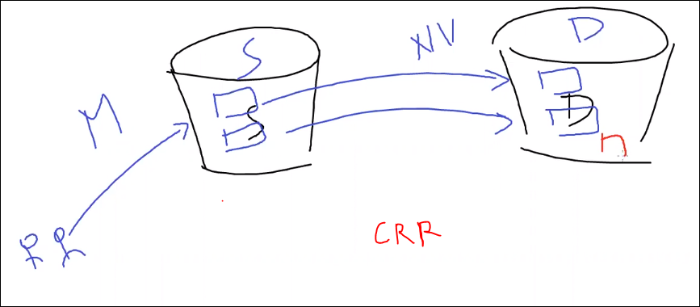

* Is it two way replication? That means if we create an object in destination and it is going to create in Source. – NO, it doesn’t create like that.

See the arrows in the picture, it is one way from source to destination.

* Is we deletes the object in Destination, it is **NOT** going to delete in Source.coz it is a back up copy and it is an object at source and it is replica in Destination, if we go to properties of an object there we can see it.
* Can we create another source from Destination? YES we can create it. As here we have “North virgina”[2] as Destination now it becomes as a “Source” and create an object in it and make it replica in another “Destination” bucket [3]. So, here whatever the new object created in [2] , can be replicated to [3], but already replicated objects in [2] can’t be replicated to [3] coz those are copies of [1].

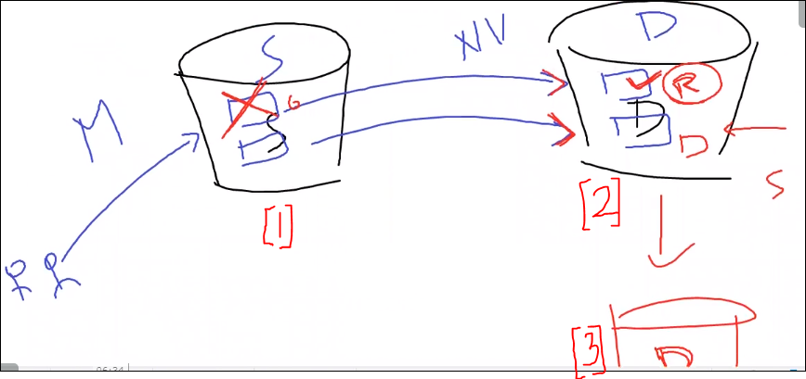

* Whatever data in source is frequently access one, and we are using S3 Standard storage class for it. And for security purpose and data loose age we are maintaining a copy in different / same region. Here the question is, is it necessary to maintain same storage class in destination bucket? and it is not frequently access[ not dally based] from destination?

Ans: NO, in that case we have an option to maintain same storage class or if we need to change the replicated object storage class, we can change it.

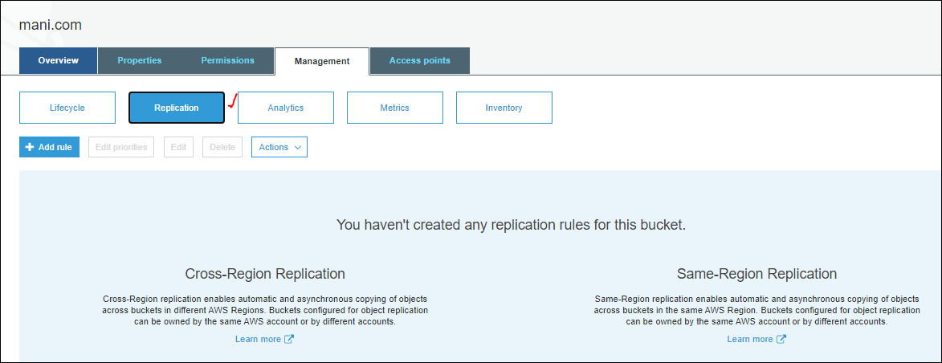

* Major part is , we need to **enable the versioning** for both source and Destination buckets to do replication. Coz individual object is going to replicate.
* Already existing data wont replicate from source to destination, as after enabling this replication in Management tab for a bucket then only future objects and sub sequent data objects can be replicated to destination. here in below image we can the replication enabled for source “lgoven” and destination”replicatest1” bucket.

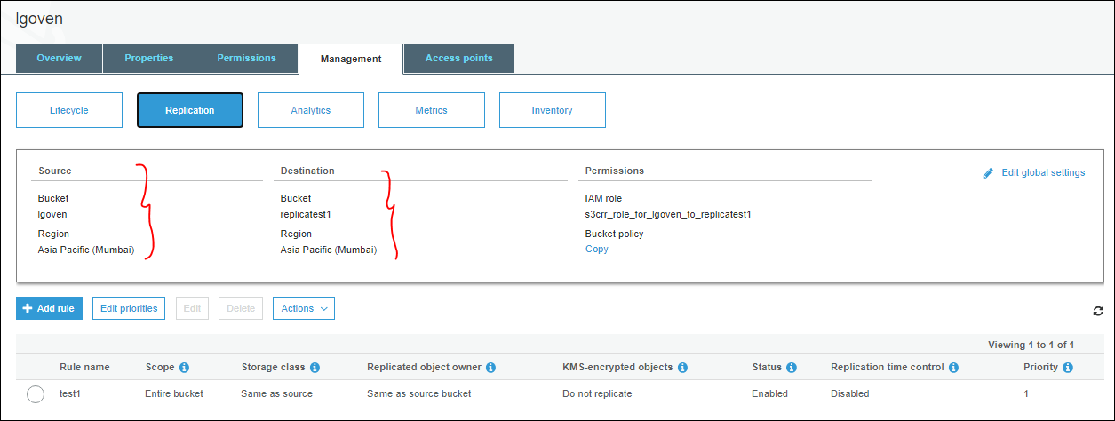

If we observe that in “lgoven” bucket, we have already existing objects before enabling the replication for it.

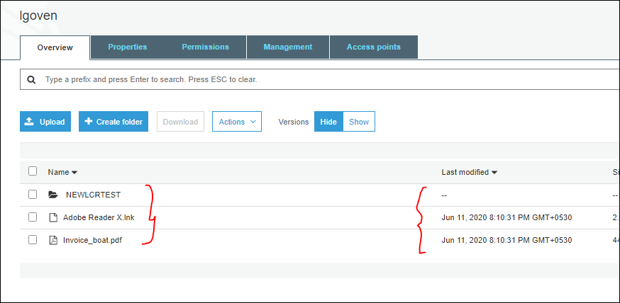

Checking in destination folder, even we don’t have any object replication as shown in the above image data object, it will be empty.

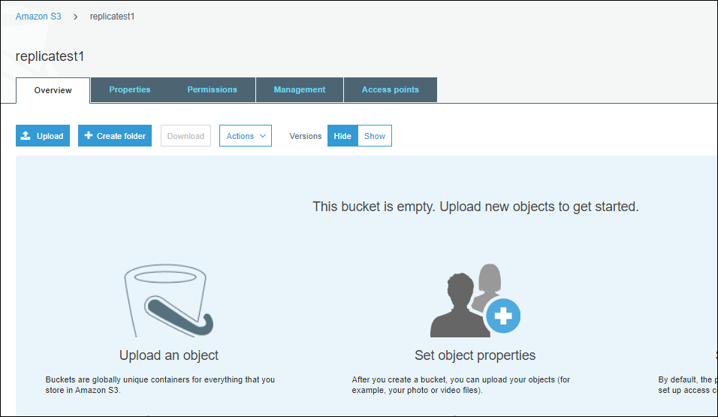

Both buckets belong to same region but created in different dates.

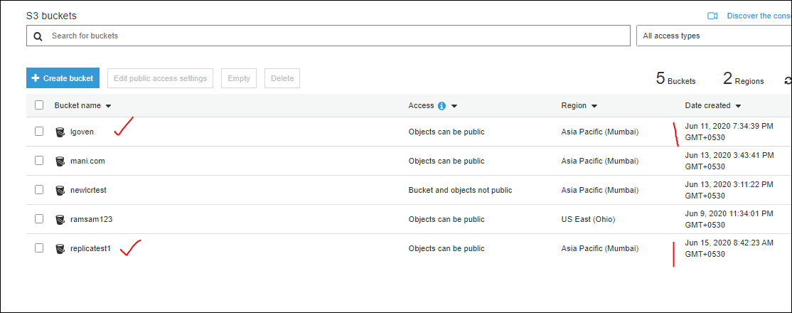

🡪manually we can copy each and every object and push into destination bucket. But Amazon has given a provision to user that he can make the data replication from source to destination,that permission we are going to provide by using “RULE” in Replication Rule window.

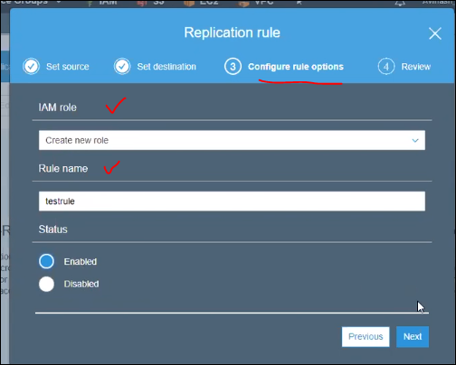

What is RULE?

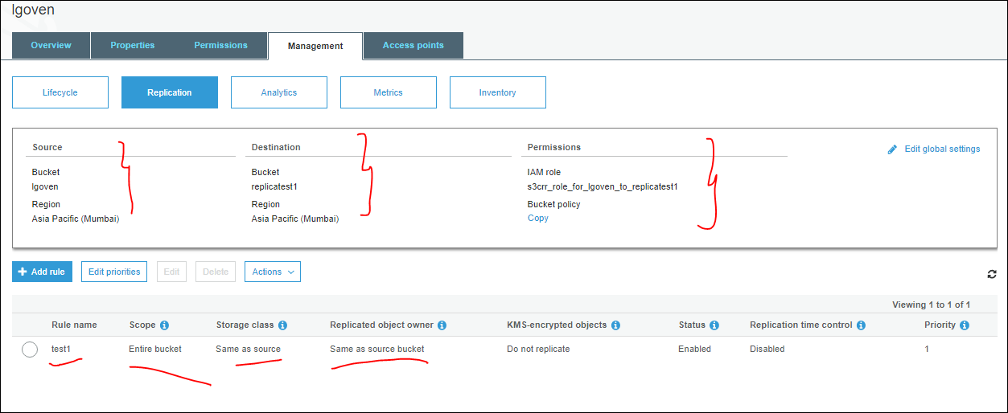

So already existing data won’t replicate to destination bucket. Now we are uploading the new data object to it. Once it uploaded then it will show the status as “Pending”.

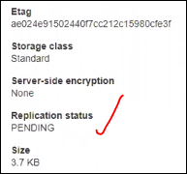

Once it is done we can see it as completed in source object Overview.

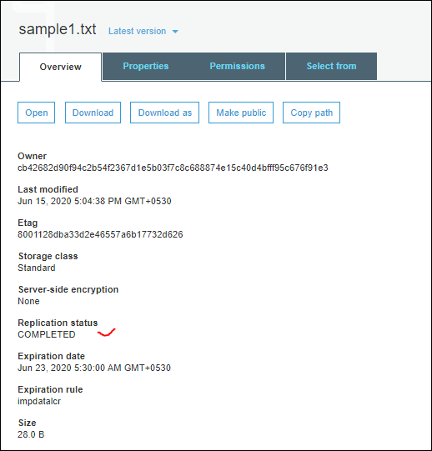

Then in destination it will be “Replica”

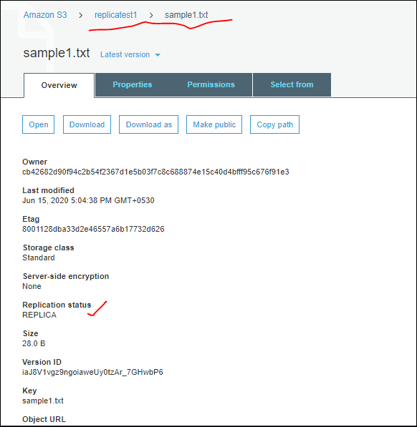

If we upload any data object to destination bucket, it won’t have that replication status. As shown below, we added an object “testsampl123”

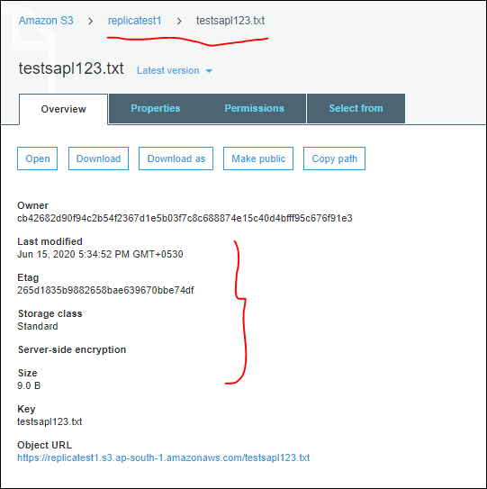

* It is not recommended to configure in reverse manner i.e., destination to source.
* One source can’t be configured to multiple destinations.

Now we are deleting the object from source bucket as shown below:

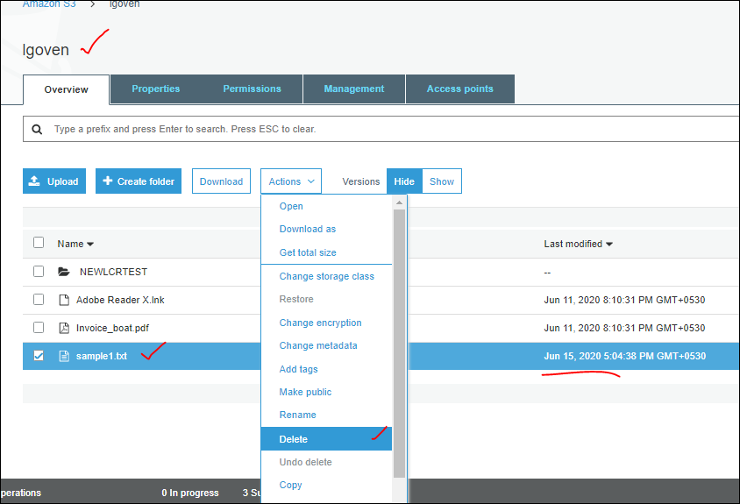

It got deleted in source bucket as shown below

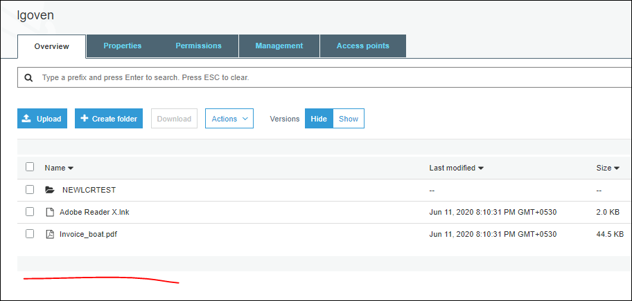

Now go to destination bucket, we can see the replication object with “replication Status as “ Replica” as shown below:

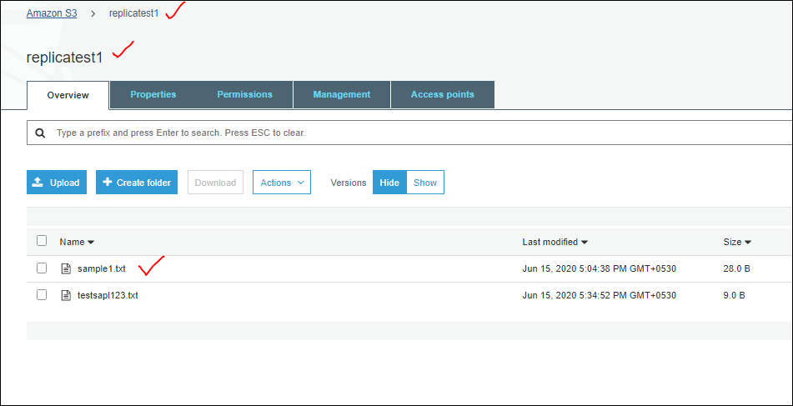

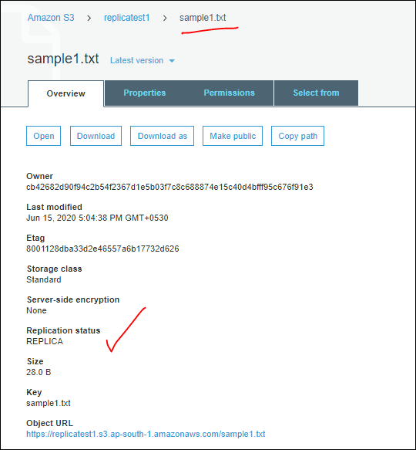

Task: Create bucket 1 and bucket 2 in Same region and configure the SRR replication between these buckets. – DONE as above.

* Basically we are creating this replication for back up purpose.
* How can we retrieve the data back once it got deleted from the source bucket?

Ans: we have an option copy in the actions which we can copy manually from the destination bucket to source file.

* But there is no **RULE** to get back the data once it got deleted.

-----------------------------------------------------------------------------------------------------------------------

**Bucket Properties 🡪 Default encryption.**

* How many types of encryption we have?

Generally we have three types of it.

1. In -Transit Encryption
2. Server side Encryption
3. Client Encryption

* **What is In-Transit Encryption?**

When data is uploading from site or downloading from site, we are enabling encryption.

Suppose we have a site with **Http** which is not secured to access any confidential data coz their might be a change of data loss which is stolen by some hackers [Man in middle attack]. So it recommended using **Https** sites.

For Https we have “SSL (Secure Socket Layer) / TLS (Transport Layer Security)” which is safe and uploaded / downloaded data can be encrypted.

But for Http we don’t have any such certificates.

Amazon is completely secured site which has both the certificates.

--> In-Transit Encryption

--> SSL (Secure Socket Layer) / TLS (Transport Layer Security)

🡪 **what is Server Side Encryption?**

After uploading the data to S3 Bucket , if we want to enable any encryption mechanism, then we can use this server side Encryption.

Server Side Encryption / at-rest it means after uploading data we are enabling encryption mechanism.]

🡪 **How many options do we have to encrypt the data?**

1. SSE - S3 (Encryption and decryption managed by s3 platform) bit less secure.

Who has valid permissions on S3 platform [like read/write..] they can encrypt or decrypt data in SSE-S3. S3 platform itself has an internal feature to encrypt data.

1. SSE – KMS [Key Management Service] (KMS Generated and Managed keys encrypt and decrypt the data)

Here we have another service KMS instead of S3, this KMS service is dedicated to design to create & manage the encrypt keys.

Here logic, algorithm is generated by KMS.

Who is generating and managing Keys?

Ans: KMS will do it.

1. SSE - C (Customer Provided) (Customer generated and uploads the keys to KMS,

KMS is going to manage the encry & Decry process)

Here we are not blindly depends on the AWs to do encryption, with help of KMS.

So by using my own software to generate the keys then going to upload the key info to customer (KMS) now KMS is going to manage encryption & Decryption process, but who has given the logic ? Customer has given the login. That mechanism is called as customer Provider.

That is SSE only but the logic is provided by customer manually instead of KMS Logic.

**Client Side Encryption**:

if we have a requirement, that Customers who don’t want to upload any unencrypted data to s3 platform, they can choose CSE. On him ON-Premise/Corporate network by using his own keys he is going to encrypt the data.. That encrypted data, we can send to aws.

Is this AWS is anything responsive to for this mechanism, we are using our own login, we are encrypting the data and that data we are uploading into AWS.

If we want to view or decrypt the data? What is the process? We need to download the data / to local machine and we can view it.

The above mentioned all are encryption mechanism.

The simplest form how encryption works as shown in below image.

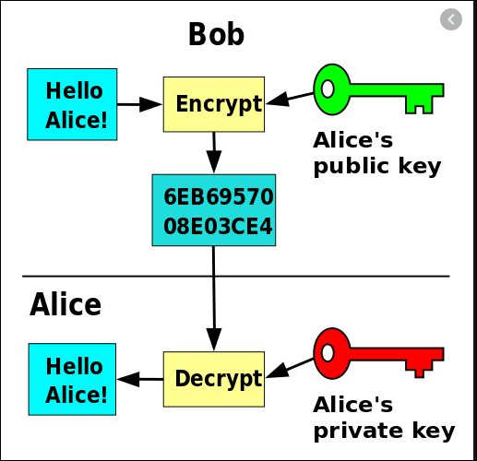

To understand this we are creating multiple IAM Users.

After creation of IAM user, for any bucket,we are going to encrypt it. Select the “AES-256

**User: arn:aws:iam::693652578065:user/test is not authorized to perform: kms:ListAliases on resource: * --** this is the error fro IAM user who doesn’t have Amdin permission. To create the encryption at object level. He is failing, so we have given admin access to “test” user then he is able to apply encrypt the object.

This is the error IAM should have admin access.

Created new user, “encpuser” before than we have given encryption “AES-256

Use Server-Side Encryption with Amazon S3-Managed Keys (SSE-S3)”

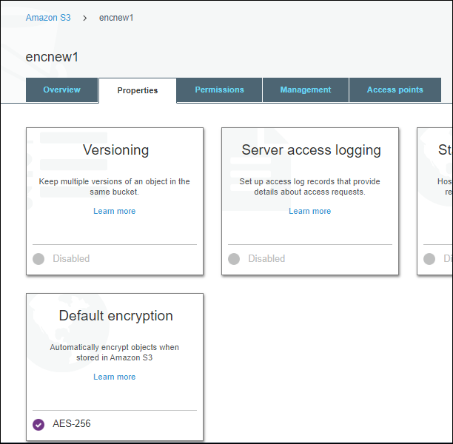

Upload a file “**testapl123”** into the bucket, “encnew1”, and try to open it, file will open with out any encryption.

Now login to **encpuser,** get into the bucket, try to open the object “testapl123” , and we are able to open the file. Without any encryption in it.

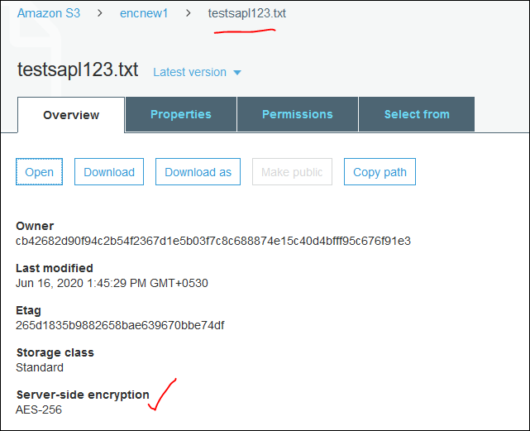

This is coz Amazon by default provide the “**AES-256**

**Use Server-Side Encryption with Amazon S3-Managed Keys (SSE-S3)”**

Now applied encryption for the object, with AWS-KMS

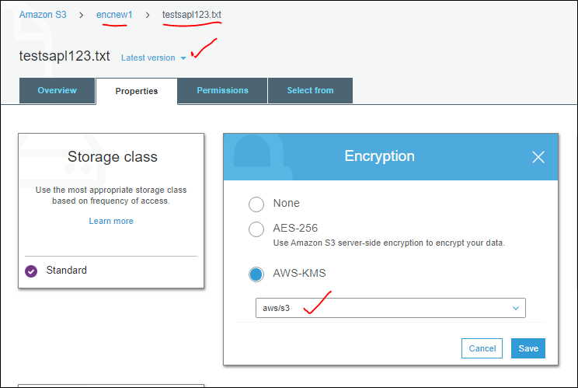

Then we can see the KMS key id generated for the object, which is not there initially. Aws/s3 is the key managed by KMS Service, shown below

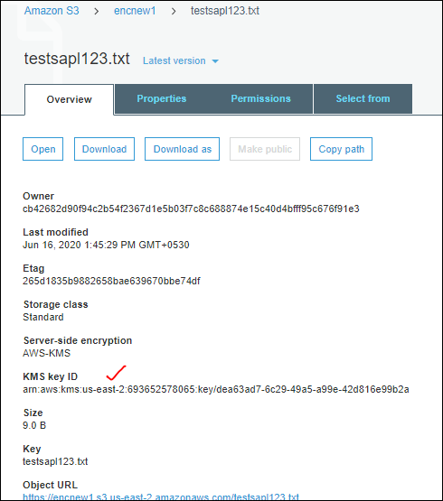

Now we will try to open the object, still it is not encrypted when suer “Ramadmin”.

And user “encpuser”

So here we done on server side encryption “**AES-256**

**Use Server-Side Encryption with Amazon S3-Managed Keys (SSE-S3)” here no KMS Key id will generate.**

**We have given any permission for the User “encpuser” but he is able to view the object content. This is coz SSE-S3 itself is a valid permissions for the user.**

KMS : : AES-256 / SSE-Se and aws/s3 ==> Whoever have valid permissions on platform they can access the data.. == FREE TIER ELIGIBILITY

There is no difference between “AES-256 / SSE-Se and aws/s3” logically. But technically [**AES-256 / SSE-Se** ] this is managed by **“S3” and “aws/s3” this is managed by “KMS”.**

* **aws/s3 this is bit more secure compared to** AES-256 / SSE-Se .
* In general we don’t use any encryption all such as [AES-256 / SSE-Se and aws/s3], if we are taking any encryption, coz who ever have access to S3 then can encrypt or decrypt it. So we generally go with another option called **customer managed Key**.
* In generally companies are investing lots of money on KMS.one key cost 1$. Basically in real time organization may have 400 keys.

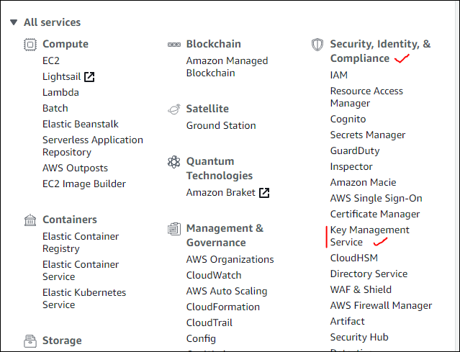

When we navigates to the key management service.

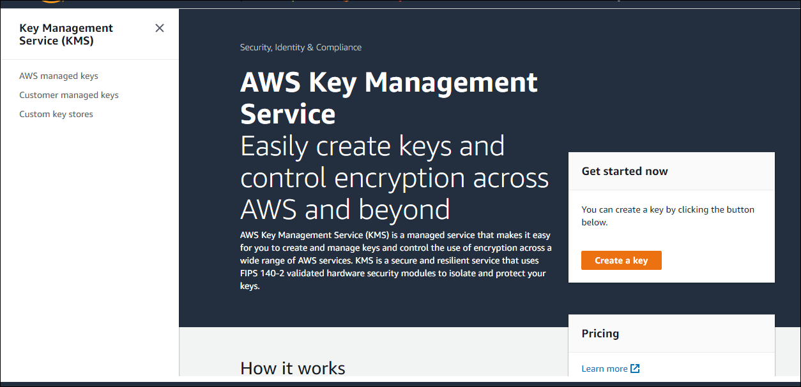

Under AWS managed keys we can see the [aws/s3] default service managed by KMS.

Customer Managed Key :

Symmetric : A single encryption key that is used for both encrypt and decrypt operations [ same key for both encryption & decryption]

Asymmetric : A public and private key pair that can be used for encrypt/decrypt or sign/verify operations [ one key for encryption and another key for Decryption]

This all KMS is going to manage.

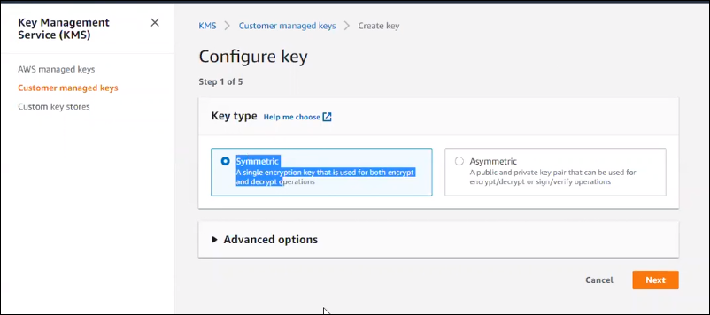

If we need to go with “SSE - C (Customer Provided) (Customer generated and uploads the keys to KMS, KMS is going to manage the encry & Decry process) “

Then we need to select “ External” in “ Advanced Options”

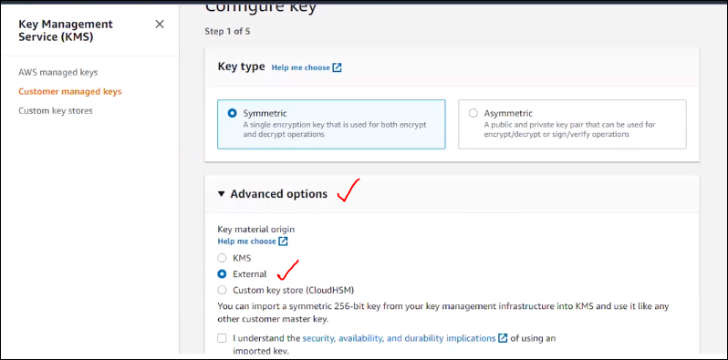

So by using this option we need to import a symmetric 256 bit key from our key management infrastructure into KMS and use it like any other customer master key.

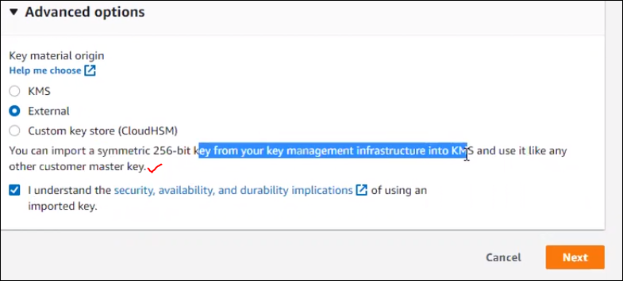

Now we will slelect KMS in the Advance for our practice purpose and click on next.we will land on this page.

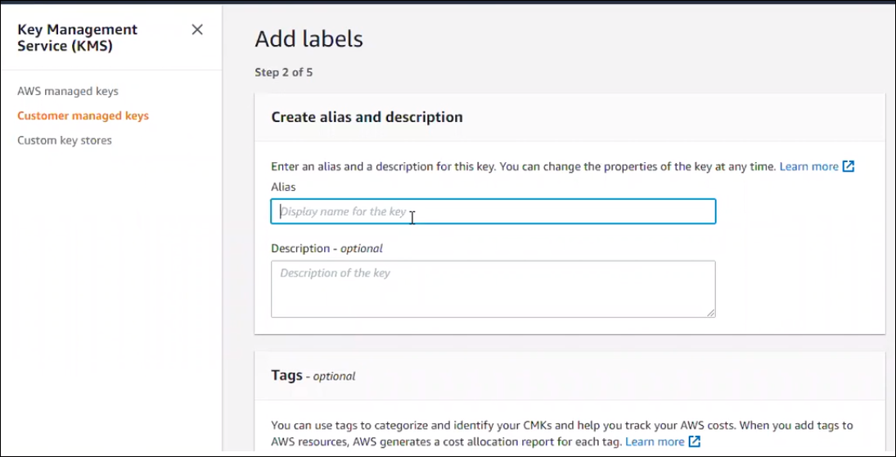

Provide values and click on next..

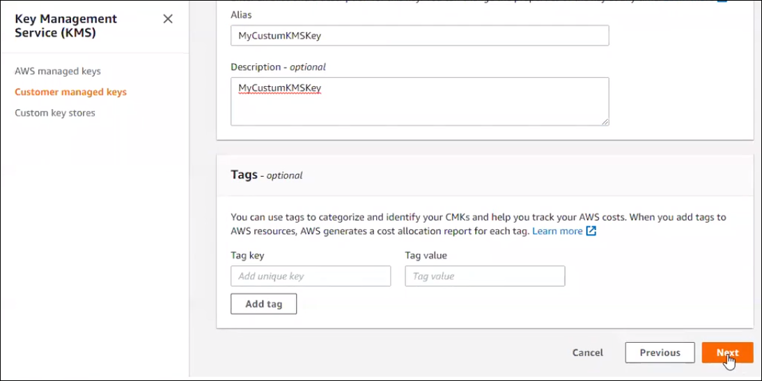

Then we need to define the key administrator permissions

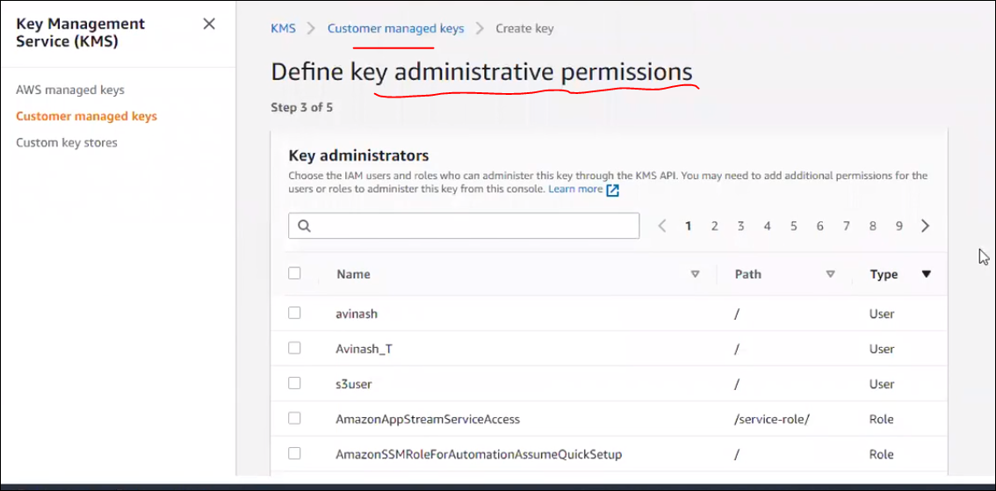

Here we have two types of permissions.

1. Key Adminstrator Permissions. [ who can create and give permissions and all to another user and all ]
2. Key usage permissions. [ it means who all allowed to use those key encryption permissions ]

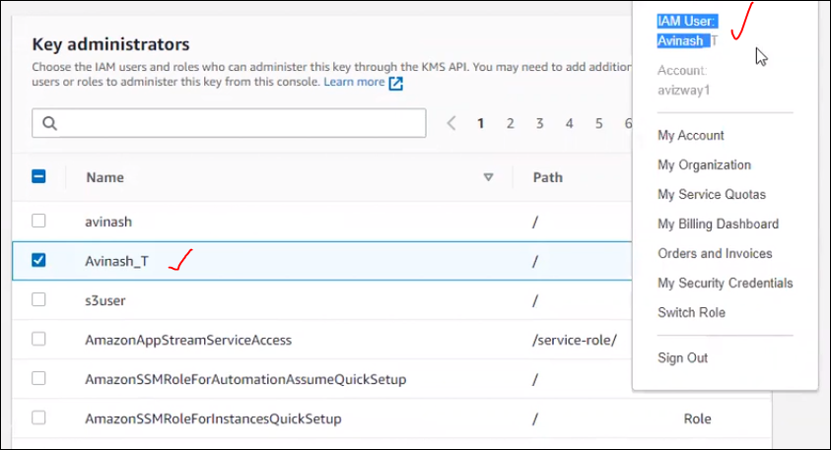

Even though he is IAM user, we are holding the permissions , in future any one want to view the encrypted data which is used by this key, they have to connect this user “ Avinash_T” for the permissions. As shown above.

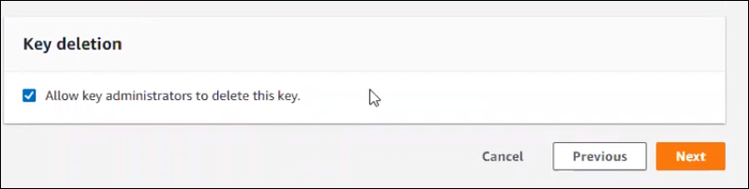

Here if we allow this above option to then in the Avinash_T user login only we can delete this key.

Now we came to “ Key usage Permissions”.

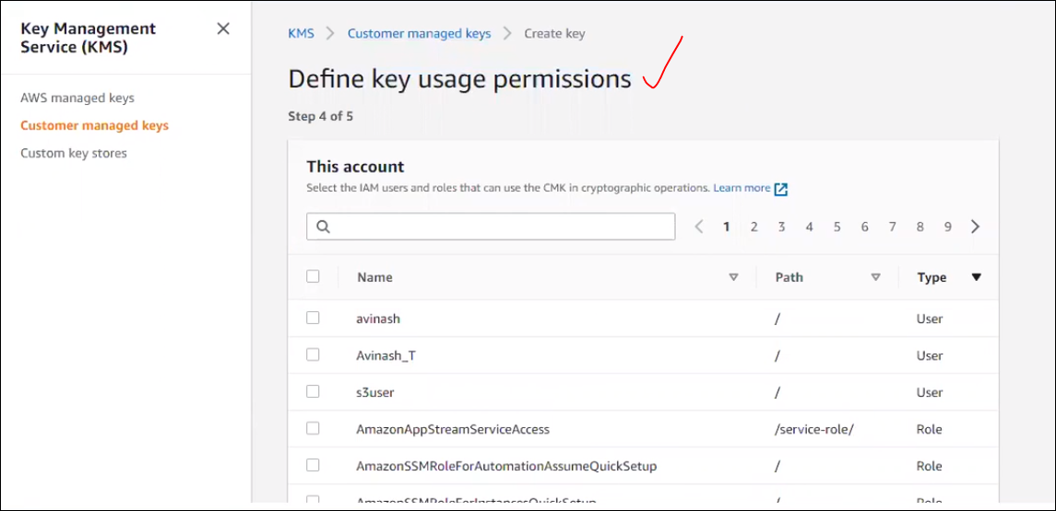

Here we can allow to use that defined key, so we are not allowing some other user to use the permission.

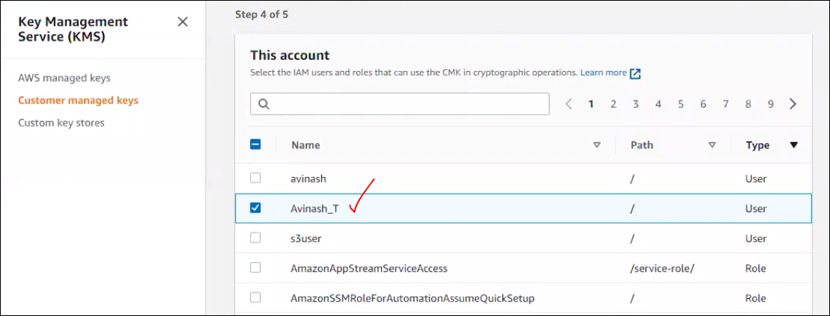

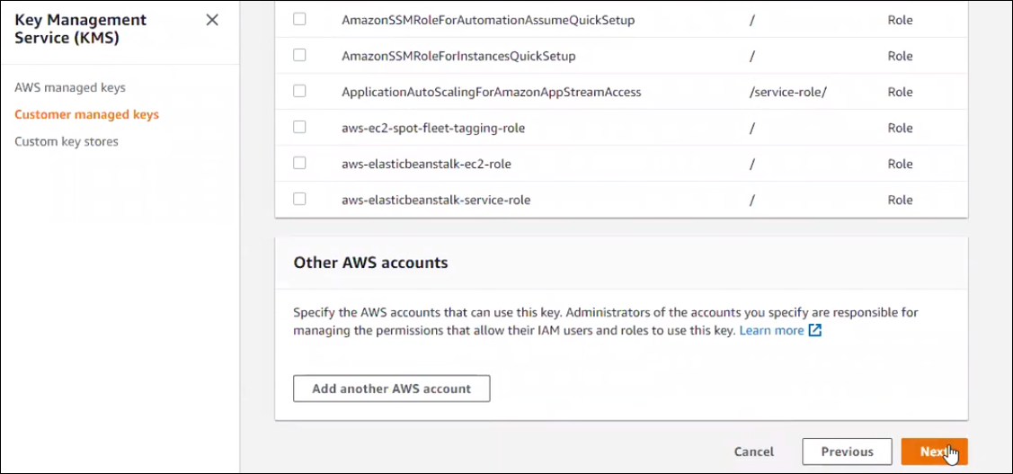

Click on next then we will be in edit key policy page.

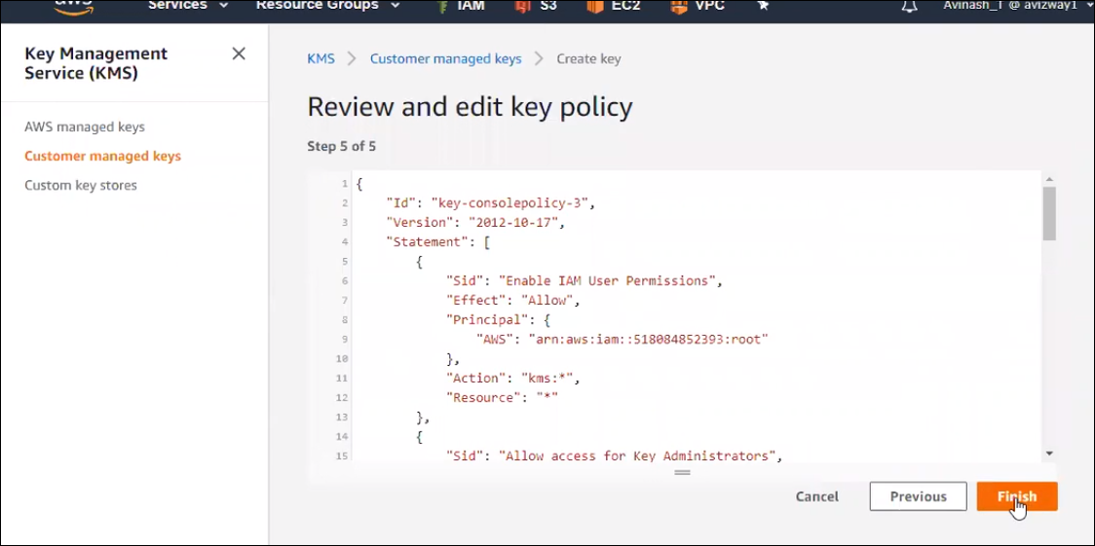

This is how we create customer managed keys.

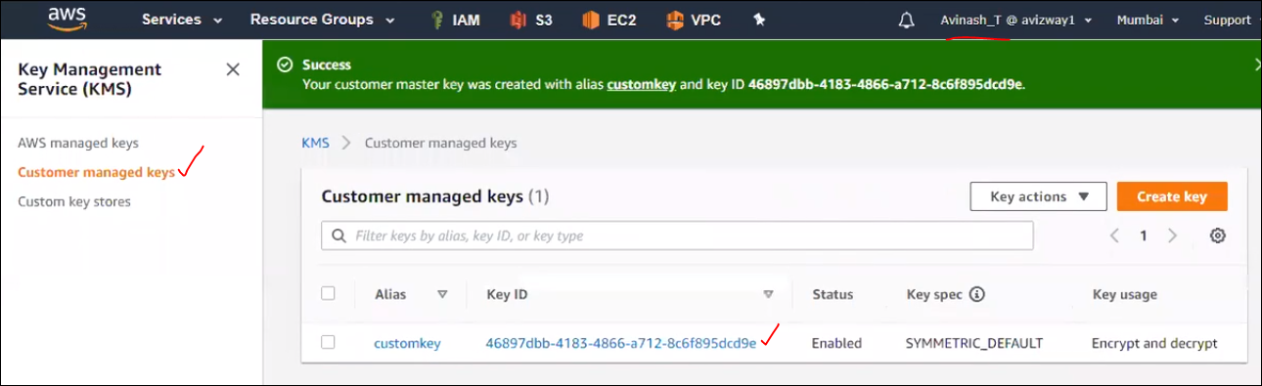

Now we are applying the customer managed key to Bucket level by the same user .

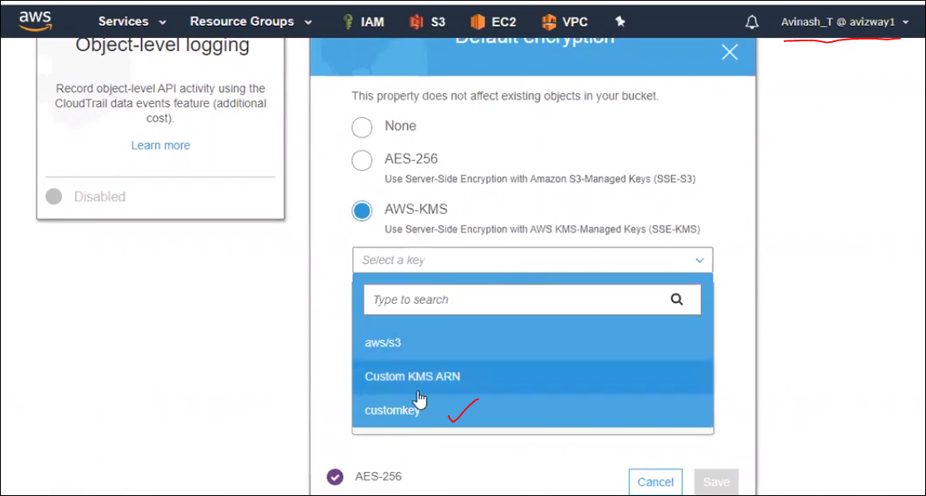

After applying the encryption for bucket level, if avainsh_T is trying to open the file, he can see it, but same file can’t be opened by other user coz we have given key usage permissions to anyone in the above flow.

So Avinash_T can open file but others can’t.

If the customer managed encryption is enabled then the server side encryption will have [ **AWS-KMS** ]

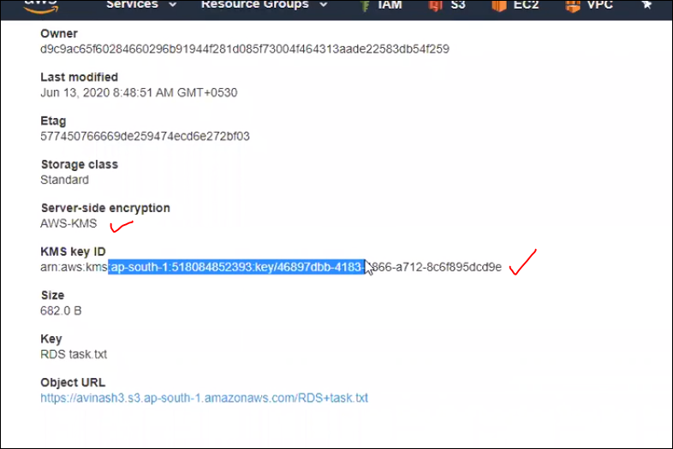

If other users try to open the same object then they can’t open the file. this is coz they don’t have key usage permission

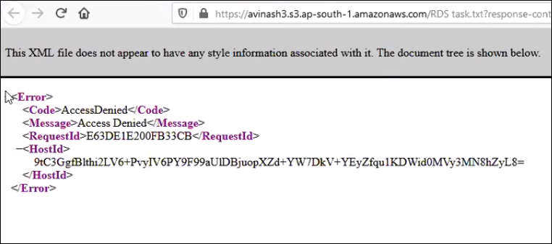

Which all files are got encrypted then those objects can’t be viewed by the users.

So we haven’t given any permission for other users.

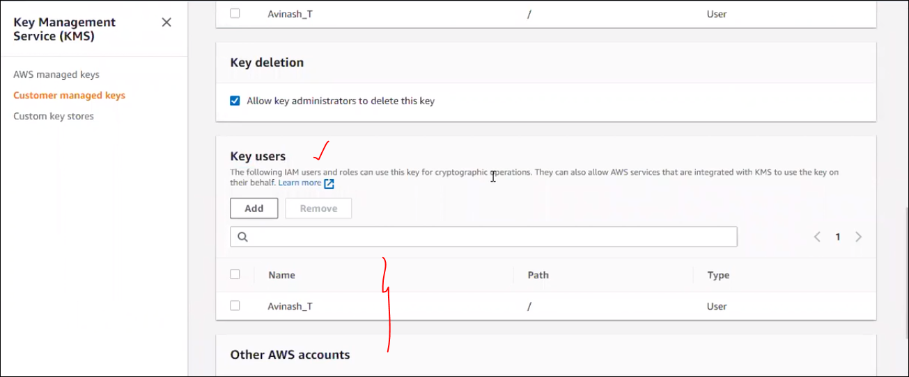

Here also we can add the permissions to other users.

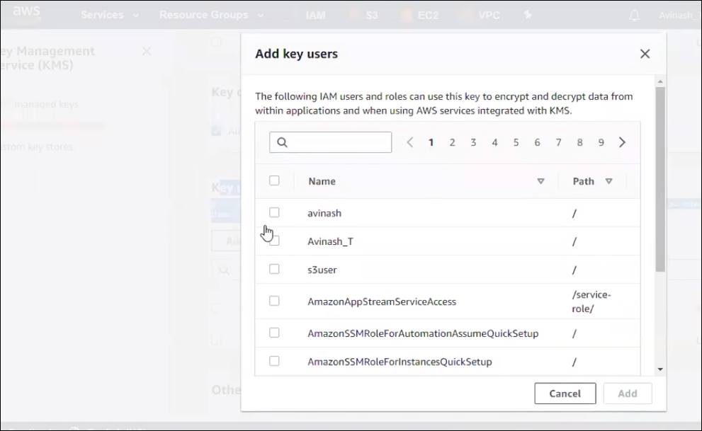

We have given permission to s3user.

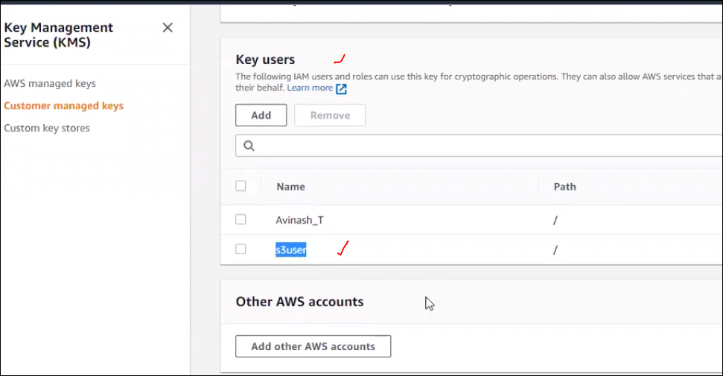

* If anyone is facing any issue with any customer encrypted we need to check these settings and provide the access to them with valid approvals.
* Generally keys are generated at application level. Eg: Bigdata app one key, sap one key….
* Now can we delete the customer managed key?

Ans: we can, coz if we have valid key delete permission then we can do it.

* Can we delete immediately? What happened to the existing data which is already encrypted by using that key? Those data can’t be retrieved, even if we call to AWS customer care also, they won’t give u any option also to retrieve data.
* That s the reason Amazon hasn’t given an option to delete the Customer key. If we need to delete we need to perform “Schedule Key Deletion”.

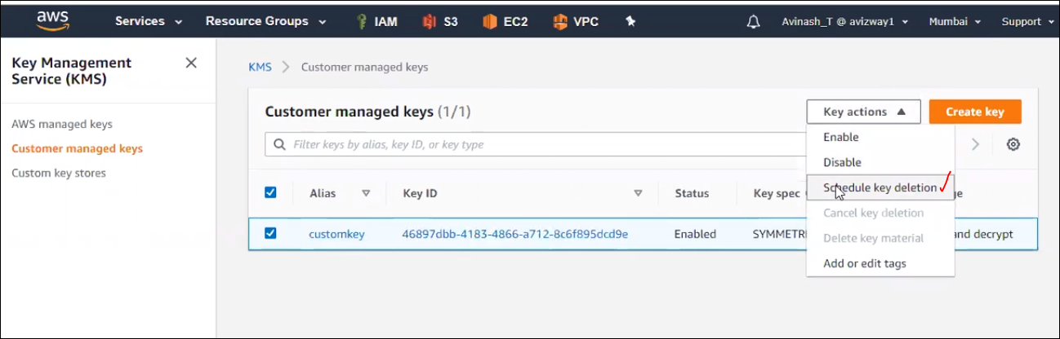

The max is 30 days , min 7 days, if we confirm after 7 days then only it will delte the key 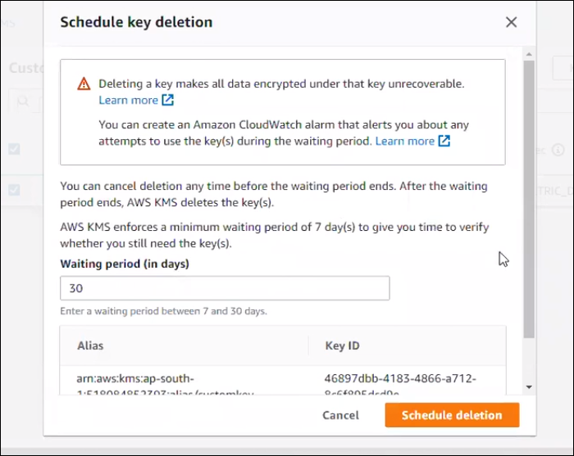

If we notice that key status will be in **pending deletion,** after schedule deletion.

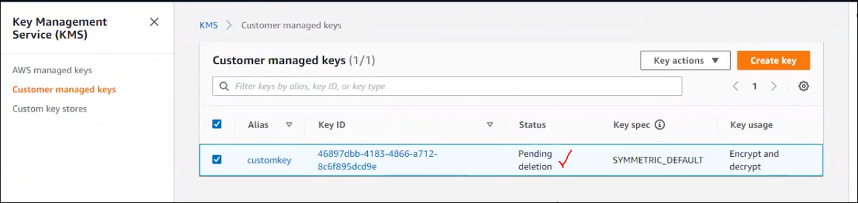

* Once we schedule the deletion of the customer key then we can’t view the encrypted object data. even by the user who has created the key he can’t view it, not only the created user but also whoever has the permission to this key they can’t view the encrypted data.

Coz the key is in pending status, it is invalid state exception

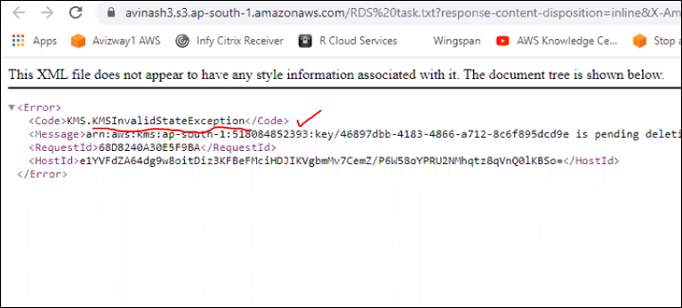

Suppose we want to cancel the key which is schedule for deletion. Go to key actions and select the “**Cancel key deletion**”.

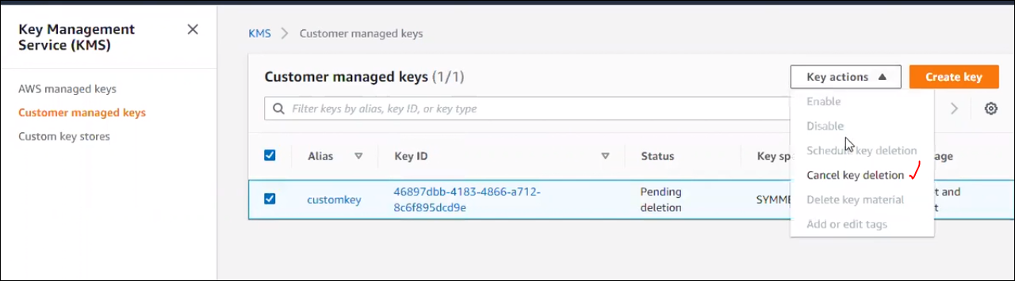

Once cancelled the schedule, the state will be in “Disabled”. But even though we can view the object data coz it will be in disabled state.

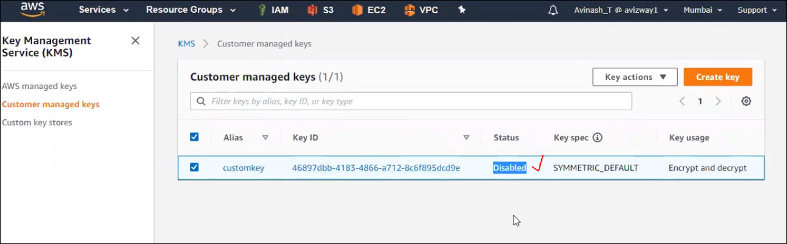

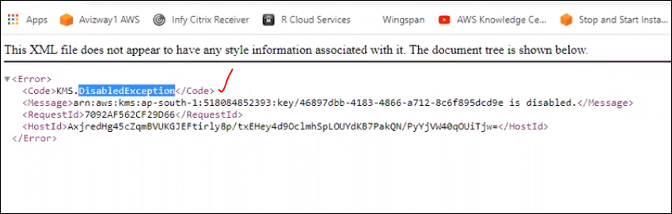

* Then how to enable this key?

Go to key actions 🡪 then click on enabled.

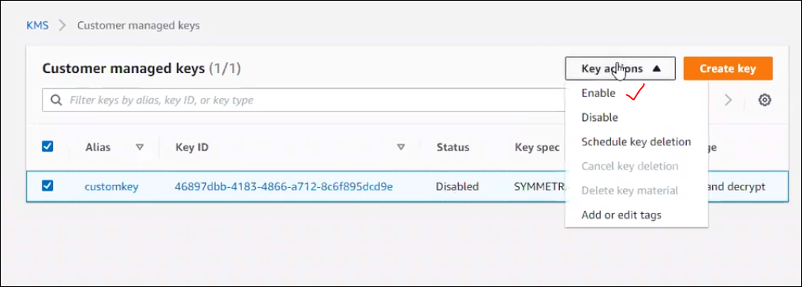

Once it is enabled we can view the data of an object which is encrypted with this key.

Key Administrator Permissions :

Key Usage Permissions :

---------------------------------------------------------------------------------------------------------------------

Interview Q&A:

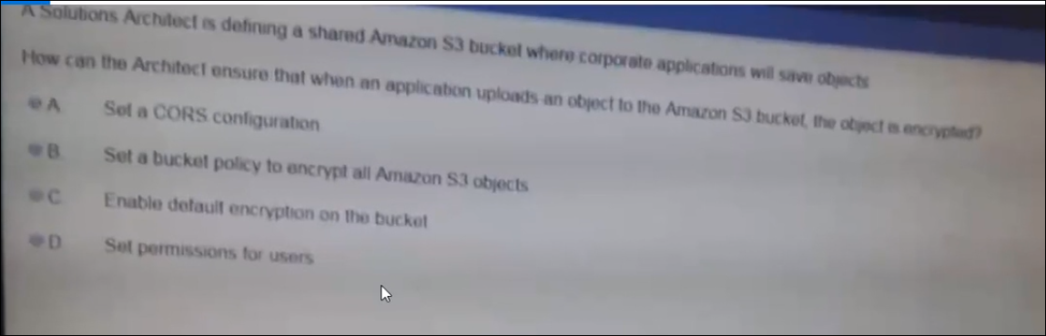

Ans: bucket policy can be taken up in next session

Bucket policy cant encrypt all the data which means which are already existing.

Ans is C

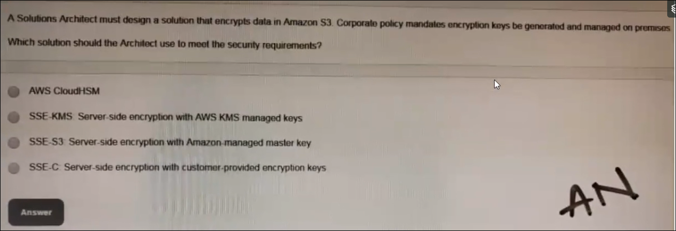

Ans: D, in question they mentioned that must design a solution, that encrypt data in S3, and Customer Provided) (Customer generated and uploads the keys to KMS, KMS is going to manage the encry & Decry process.

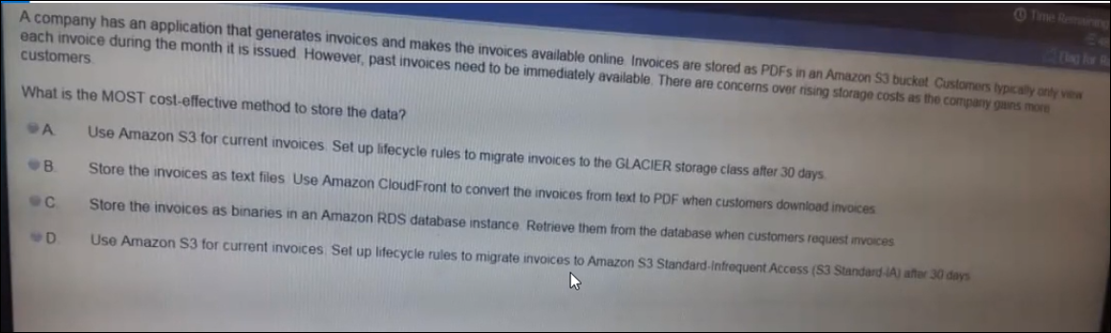

Ans: D

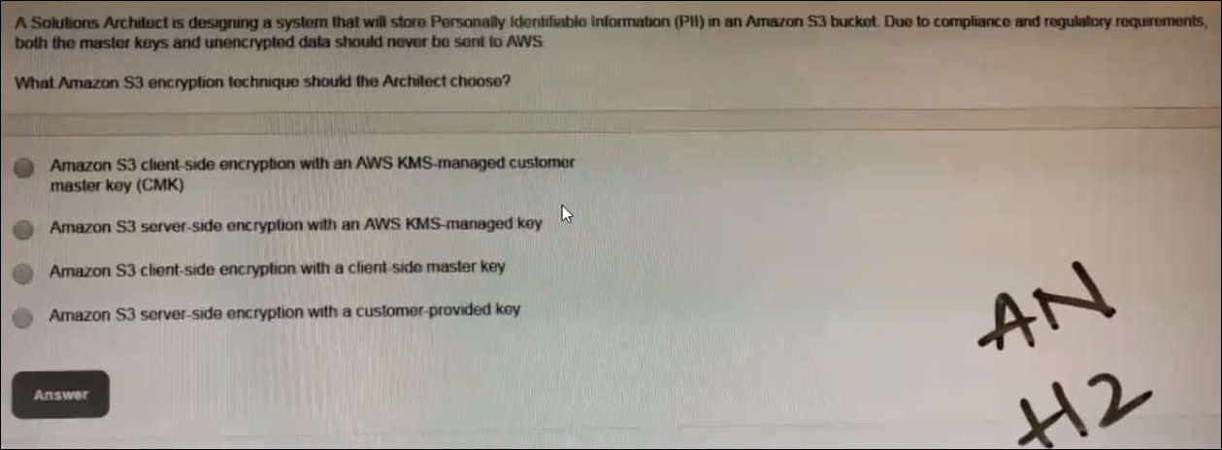

Ans: C

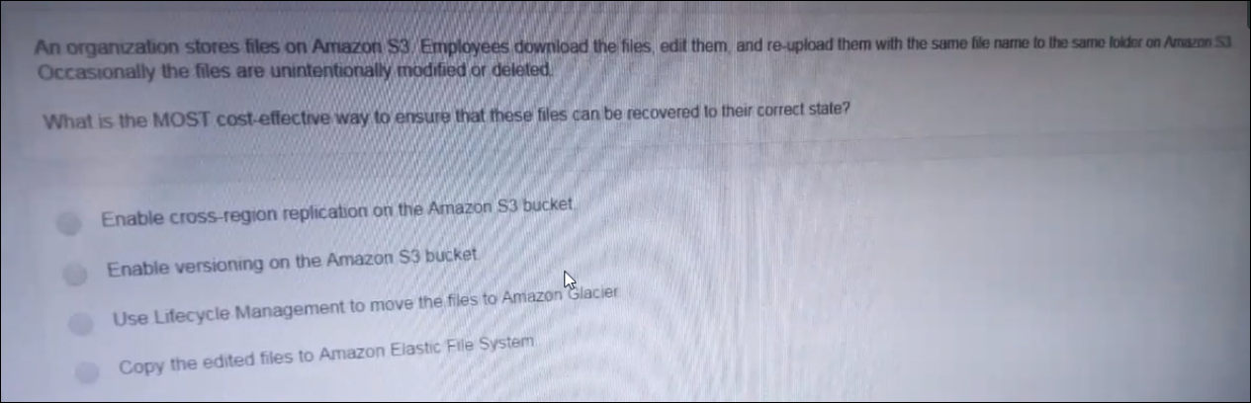

Ans: B.